宁波甬洁溢油应急服务有限公司

中英文污染清除作业方案

Ningbo Yongjie Ship Pollution Emergency
Response CO.,Ltd

Pollution Response Operation Plan

二〇二三年一月
January 2023
宁波舟山港污染清除作业方案
宁波甬洁溢油应急服务有限公司设立船舶污染事故应急指挥部，负责组织实施本方案。
对溢油事故进行评估，确定溢油的程度及其规模，测算溢油量的大小。
在相关部门统一指挥下，建立健全分类管理、分级负责制度，充分发挥应急指挥机构的作用。应急组织机构具体如下：
宁波甬洁溢油应急服务有限公司船舶污染应急响应指挥部由以下成员组成：
总指挥，现场指挥，应急工作小组，海上应急组， 岸基应急组，机动联络组，后勤保障组，必要时聘请专家组。
我司按照下图所示进行应急处置流程：

宁波舟山海域溢油影响预测评价及清污方案如下:
模拟结果中，红色为水面浮油，橙色为上岸溢油，黄色为溢油扫海痕迹。红色圆形标记为度假旅游区，绿色圆形标记为风景旅游区，黑色圆形鸟形标记为自然保护区。
宁波某水域
4000吨中东原油、持续泄漏2小时，冬季大潮涨憩，风向NNW，风速5m/s，溢油在泄漏后，我司运用溢油模拟软件模拟出在落潮流和风的作用下，溢油3h到达穿山半岛北侧，6h全部到达岸边，此后在NNW风压下，基本稳定在这个区域，没有进一步漂移扩散。
溢油扩散范围较小，由于集中在穿山半岛北岸，溢油并没有全部上岸，4000吨溢油中仅有1500吨上岸，大部分仍然漂浮在岸边，造成的污染损害相对较小。
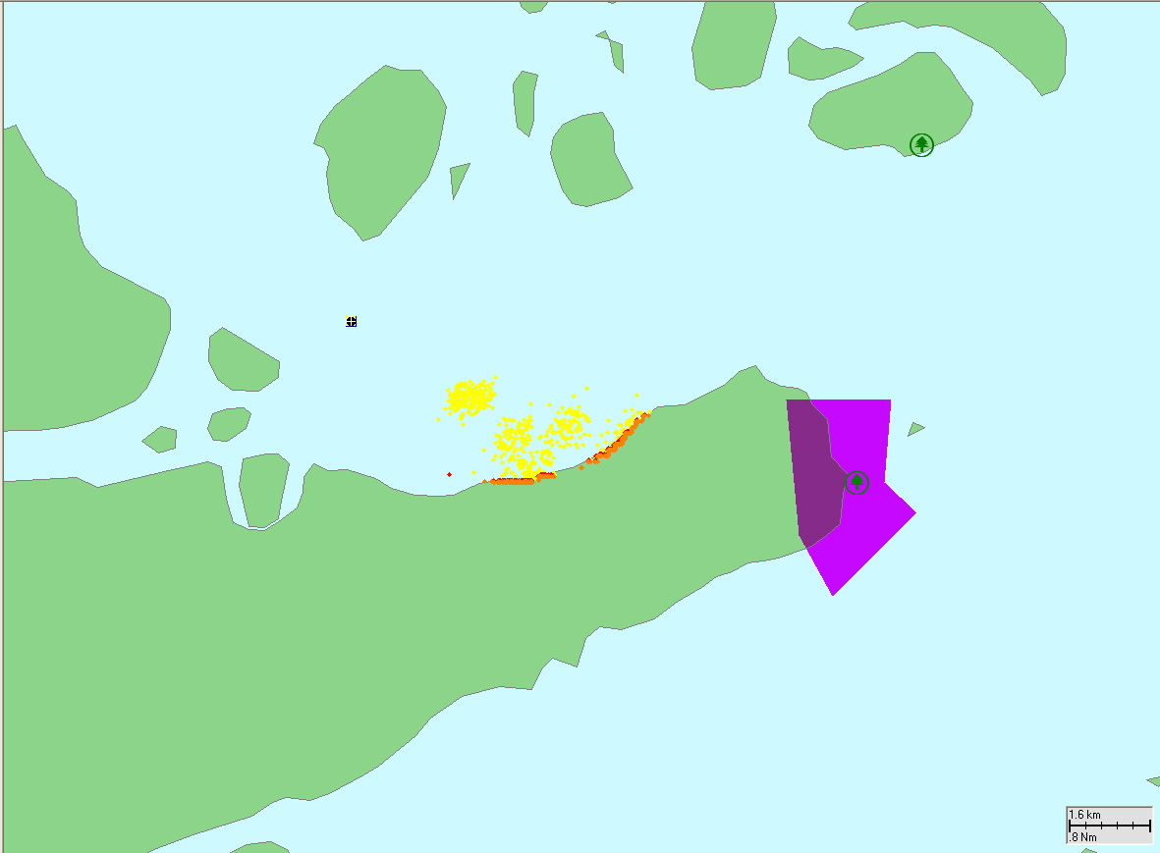
泄漏后3小时
清除作业方案：
（一）参与溢油应急行动总名单
宁波甬洁溢油应急服务有限公司船舶污染应急响应指挥部:
总指挥：王世华；现场指挥：俞世雄。
应急工作小组:
海上应急组职责：海上工作支持。
岸基应急组职责：溢油现场岸基应急。
机动联络组职责：应急机动、联络通讯保障。
后勤保障组职责：后勤支援。
（二）应急总指挥部电话
甬洁公司办公室电话：0574-27996899， 传真0574-27996898。
应急处置部电话：0574-27996855，传真0574-27996860。
江南红联码头电话：0574-86197110， 传真0574-86197110。
大榭基地码头电话：0574-86767950， 传真0574-86767950。
（三）应急启动程序及指挥层构设置
1.公司设立应急指挥中心，成员由公司高层、高级指挥人员组成，负责船舶污染应急防备和应急清除工作的组织和指挥，并设日常办公机构，主要部门应急处置部，负责应急指挥中心的日常工作。本应急预案一经启动，在原应急指挥中心基础上立即成立应急指挥部，协调、组织和指挥公司内部应急反应行动。
应急指挥部成员由公司执行董事、总经理、应急处置部、综合办公室、业务部以及财务部相关成员组成。
总指挥可由应急指挥部指定，必须是高级指挥人员。总指挥应当具备对船舶污染事故应急反应的宏观掌控能力，能够根据事故情形综合评估风险，及时做出应急反应决策，有效组织实施，取得培训合格证书。
2.本应急预案一经启动，事故清污现场立即成立应急工作小组。应急工作小组组长由应急指挥部指派。应急工作小组下设：海上应急组、岸基应急组、机动联络组、后勤保障组，必要时聘请船舶污染应急方面的专家组成专家咨询组。
3.在节假日及夜间时，由应急处置部负责人先行组织应急清污行动，并迅速向公司应急指挥部报告。当事故清污现场成立应急工作小组后，先期处置负责人应将指挥权移交现场应急工作小组组长。
(四)各岗位分工及职责
1.应急指挥部
（1）负责应急预案中本公司各项应急处置行动的全局指挥和协调。
（2）根据污染规模和发展态势，批准应急清污抢险方案的实施。
（3）负责应急清污抢险方案和清污信息等重大事项的签署和上报。
（4）协调与上级（相关机关）的信息沟通与协同配合工作。
（5）根据事态发展和需要，召集专家咨询组研究应急清污方案等。
（6）根据事态的严重程度，通知协议公司舟山中海洗舱有限公司对应急操作人员进行支援（0580-2381005）。
（7）根据事态的严重程度，协调宁波海安公司(电话0574-87669285),舟山海安公司根据与我司签订的应急处置合作协议进行支援(电话0580-8806085)。
2.应急工作小组
（1）接受相关机关和指挥部指令，组织指挥污染围控和清污工作。
（2）及时掌握清污现场情况，评估应急清污抢险方案的有效性。
（3）与应急指挥部保持有效通讯联系，做好现场信息反馈和记录。
（4）督察现场应急清污作业，配合解决清污现场的各类具体问题。
（5）负责清污抢险行动的后勤保障、人员防护和力量调配工作。
3.相关部门职责
（1）海上应急组：海上工作支持
①负责水域船舶污染监视和协议船舶的污染应急防备工作。
②根据公司应急清污方案组织实施污染现场的应急清污行动。
③及时向应急指挥部报告事故现场应急清污的紧急重要情况。
④负责当日现场船舶的调度等工作。
（2）岸基应急组：溢油现场岸基应急
①负责岸基应急人员的日常管理和培训、演练、考核等工作。
②负责应急清污行动中岸基人员和设备调配及作业安全工作。
③督察现场应急清污作业，配合解决清污现场的各类具体问题。
④负责做好应急行动的信息记录、总结评估和费用清算工作。
（3）机动联络组：应急机动联络、通讯、设备交通装运等
①与应急指挥部保持有效通讯联系，做好现场信息反馈和记录。
②负责在紧急情况下的计算机网络、通讯联络的畅通；及时做好应急指挥部、应急工作小组及内部各应急作业组成员的信息联系以及周边相关单位和上级领导之间的信息传递与沟通。
③协助做好应急清污行动中设备、器材的装调运。
④协助做好应急行动的信息记录、总结评估和费用清算工作。
⑤整理所有物资出入库材料，船舶使用清单等相关理赔材料。
（4）后勤保障组：后勤支援
① 负责应急清污行动中通讯器材、车辆调配等后勤保障工作。
② 负责应急清污行动中医疗救护、膳食住宿、人员接待工作。
③负责提供船舶污染应急清污行动的资金保障和支持工作。
④负责应急清污专家的接待及相关会议的召开工作。
（五）应急处置现场应急实施方案
海上应急组组长立刻赶往停靠在大榭客运码头应急停靠点的溢油应急船“甬洁1”船上并指挥赶往事发现场，利用船上的充气式围油栏先行对溢油进行围控，并用船上的收油机对围控的溢油进行有效回收。
岸基应急组组长立即调配溢油物资到应急船上，海上应急组副组长立刻带领其他相关操作人员携带溢油应急物资指挥另外一条停靠在江南1号码头的溢油应急船“甬洁5”及相关辅助船赶往现场进行支援。根据当时的潮流、风向、风速等条件，在穿山半岛北侧提早布防浮子式围油栏，同时可以采取两船J形布防围油栏对溢油进行有效的围控和回收。
应急操作人员协助溢油应急船上人员对溢油发生地点的搁浅或碰撞船舶进行卸载作业，将过驳的油类临时存储在溢油应急船油舱内。辅助船上操作人员负责向海面抛投和回收吸油毡。
当海面油污基本清理完毕，使用收油机、吸油毡等都无法有效回收溢油的情况可使用具有生物降解功能的溢油分散剂。
在全面使用各类清污技术的同时我司将根据各种直接因素和间接因素的影响根据现场的实际情况，及时调整应对策略，最大限度地发挥出所用技术的最佳效果。
同时向相关部门及时作好汇报工作，对溢油的程度，规模，采取的围控方式，取得的效果和现场的情况进行实时报告。
后勤保障组负责为海上应急组及其他相关部门提供安全防护服，对讲机，安全帽，医疗应急物品，资金保障。
回收的油类、类油物和沾油废弃物由宁波甬洁溢油应急服务有限公司办理相关手续和网上申报后交由协议单位对回收的污染物进行清理与无害化处理。
在油污应急行动中由各部门做好各项记录。对各类记录表格和收集的事故描述、各项数据予以记录并整理。
各部门对水上油污事故的控制、监视、清除中所投入的人力资源、物力资源（派出人次、动用船艇的总艘次、调配防污染设备和器材的种类及数量、花费的时间和费用等）做详细的文字记录备查。
各部门将清污工作过程（出动清污队伍的人次和时间、动用清污设施设备及器材的种类数量和时间、各协作部门的费用支出明细情况等）进行文字记录。
对该水域清污工作完成后，由总指挥向当地相关部门申请清污工作结束，在得到相关部门的批准后方可结束全部的溢油应急程序。
溢油应急终止后,宁波甬洁溢油应急服务有限公司组织全体参与人员进行溢油应急响应评估工作，整理和审查溢油应急记录和相关资料。

Ningbo Zhoushan Port Pollution Removal Operation Plan
Ningbo Yongjie Ship Pollution Emergency Response Co., Ltd. has established an emergency command center for ship pollution accidents, responsible for organizing the implementation of this plan.
Evaluate oil spill accidents, determine the extent and scale of the oil spill, and calculate the magnitude of the oil spill.
Under the unified command of relevant departments, establish and improve a classification management and hierarchical responsibility system, and fully leverage the role of emergency command institutions. The specific emergency organization structure is as follows:
The ship pollution emergency response command center of Ningbo Yongjie Ship Pollution Emergency Response Co., Ltd. is composed of the following members:
Commander in chief, on-site commander, emergency work team, offshore emergency team, shore based emergency team, mobile liaison team, logistics support team, and if necessary, hire expert team.
Our company follows the emergency response process as shown in the following figure:
The prediction and evaluation of the impact of oil spills in the Ningbo Zhoushan sea area and the pollution removal plan are as follows:
In the simulation results, red represents floating oil on the water surface, orange represents onshore oil spill, and yellow represents oil spill sweeping marks. The red circle is marked as a vacation tourist area, the green circle is marked as a scenic tourist area, and the black circle is marked as a bird shaped nature reserve.
A certain water area in Ningbo
4000 tons of Middle Eastern crude oil leaked continuously for 2 hours. During winter, the spring tide was rising and the wind direction was NNW, with a wind speed of 5m/s. After the oil spill, our company used oil spill simulation software to simulate that under the action of falling tide and wind, the oil spill reached the north side of the Chuanshan Peninsula in 3 hours, and all reached the shore in 6 hours. Afterwards, under the NNW wind pressure, it basically stabilized in this area without further drift and diffusion.
The spread range of the oil spill is relatively small. Due to its concentration on the north bank of the Chuanshan Peninsula, not all of the spilled oil has landed. Out of 4000 tons of spilled oil, only 1500 tons have landed, and most of them are still floating on the shore, causing relatively small pollution damage.
3 hours after leakage
Pollution Response Operation Plan
（1） List of Participants in Oil Spill Emergency Action
Ningbo Yongjie Ship Pollution Emergency Response Co., Ltd.Ship Pollution Emergency Response Command:
Commander in Chief: Wang Shihua; On site commander: Yu Shixiong.
Emergency working group:
Responsibilities of the offshore emergency team: support for offshore work.
Responsibilities of the shore based emergency team: shore based emergency response at oil spill sites.
Responsibilities of the Mobile Liaison Group: Emergency mobilization, liaison and communication support.
Logistics Support Team Responsibilities: Logistics support.
（2） Emergency Command Headquarters Telephone
Yongjie Company Office Phone: 0574-2796899, Fax: 0574-2796898.
Emergency Response Department phone number: 0574-2796855, fax number: 0574-2796860.
Jiangnan Honglian Wharf phone number: 0574-86197110, fax number: 0574-86197110.
Daxie Base Wharf Phone: 0574-8677950, Fax: 0574-86767950.
（3） Emergency initiation procedure and command layer structure setting
1. The company shall establish an emergency command center, consisting of senior management and commanding personnel responsible for organizing and directing emergency prevention and removal of ship pollution. The center shall also have a daily office structure, with the main department being the Emergency Response Department, responsible for the daily work of the emergency command center. Once this emergency plan is activated, an emergency command center will be immediately established on the basis of the original emergency command center to coordinate, organize, and command internal emergency response actions of the company.
The members of the emergency command center are composed of the company's executive director, general manager, emergency response department, comprehensive office, business department, and relevant members of the finance department.
The overall commander can be designated by the emergency command center and must be a senior commander. The overall commander should have the macro control ability of emergency response to ship pollution accidents, be able to comprehensively evaluate risks based on the accident situation, make emergency response decisions in a timely manner, effectively organize implementation, and obtain training certificates.
Once this emergency plan is activated, an emergency working group will be established immediately at the accident cleaning site. The leader of the emergency work group is appointed by the emergency command center. The emergency working group consists of a maritime emergency group, a shore based emergency group, a mobile liaison group, and a logistics support group. When necessary, experts in ship pollution emergency response are hired to form an expert consulting group.
During holidays and at night, the person in charge of the emergency response department shall first organize emergency clean-up actions and promptly report to the company's emergency command center. After the emergency work team is established at the accident cleaning site, the person in charge of the initial disposal should transfer the command power to the leader of the on-site emergency work team.
（4） Division of labor and responsibilities for each position
1. Emergency Command Center
(1) Responsible for the overall command and coordination of various emergency response actions in the company's emergency plan.
(2) Approve the implementation of emergency cleaning and rescue plans based on the scale of pollution and development trends.
(3) Responsible for signing and reporting major issues such as emergency cleaning and rescue plans and cleaning information.
(4) Coordinate information communication and collaborative work with superiors (relevant authorities).
(5) According to the development and needs of the situation, convene an expert consultation group to study emergency cleaning plans, etc.
(6) According to the severity of the situation, notify the agreement company Zhoushan Zhonghai Cabin Washing Co., Ltd. to provide support to emergency operators (0580-2381005).
(7) Based on the severity of the situation, coordinate with Ningbo Haian Company (phone number 0574-87669285), and Zhoushan Haian Company to provide support according to the emergency response cooperation agreement signed with our company (phone number 0580-8806085).
2. Emergency working group
(1) Accept instructions from relevant authorities and command centers, organize and command pollution control and cleaning work.
(2) Timely grasp the situation of the cleaning site and evaluate the effectiveness of emergency cleaning and rescue plans.
(3) Maintain effective communication with the emergency command center, and provide on-site feedback and records.
(4) Supervise on-site emergency cleaning operations and cooperate in solving various specific problems at the cleaning site.
(5) Responsible for logistics support, personnel protection, and force allocation for pollution control and emergency operations.
3. Responsibilities of relevant departments
(1) Offshore Emergency Team: Offshore Work Support
① Responsible for monitoring ship pollution in water areas and emergency prevention of pollution from contracted ships.
② Organize and implement emergency cleaning actions for pollution sites according to the company's emergency cleaning plan.
③ Report to the emergency command center in a timely manner the urgent and important situation of emergency cleaning at the accident site.
④ Responsible for the scheduling of on-site vessels on the day.
(2) Shore based emergency team: Shore based emergency response at oil spill site
① Responsible for the daily management, training, drills, assessments, and other work of shore based emergency personnel.
② Responsible for the deployment of shore based personnel and equipment, as well as operational safety during emergency clean-up operations.
③ Supervise on-site emergency cleaning operations and cooperate in solving various specific problems at the cleaning site.
④ Responsible for recording information, summarizing and evaluating emergency actions, and clearing expenses.
(3) Mobile liaison group: emergency mobile liaison, communication, equipment transportation and shipment, etc
① Maintain effective communication with the emergency command center, and provide on-site feedback and records.
② Responsible for ensuring smooth computer networks and communication in emergency situations; Timely establish information communication between the emergency command center, emergency work team, and members of various internal emergency operation teams, as well as information transmission and communication between surrounding relevant units and superiors.
③ Assist in the installation and transportation of equipment and equipment during emergency cleaning operations.
④ Assist in recording information, summarizing and evaluating emergency actions, and clearing expenses.
⑤ Organize all materials for inbound and outbound shipments, ship usage lists, and other related claims materials.
(4) Logistics Support Group: Logistics Support
① Responsible for logistics support work such as communication equipment and vehicle allocation during emergency cleaning operations.
② Responsible for emergency cleaning operations
（5） Emergency response on-site emergency implementation plan
The leader of the maritime emergency team immediately rushed to the oil spill emergency ship "Yongjie 1" docked at the emergency stop of Daxie Passenger Terminal and commanded them to rush to the scene of the incident. They used the inflatable oil boom on the ship to first control the oil spill and effectively recovered the controlled oil using the ship's oil receiver.
The leader of the shore based emergency team immediately deployed oil spill supplies to the emergency ship, and the deputy leader of the offshore emergency team immediately led other relevant operators to carry oil spill emergency supplies and commanded another oil spill emergency ship "Yongjie 5" and related auxiliary ships docked at Jiangnan No.1 dock to rush to the scene for support. According to the current, wind direction, wind speed and other conditions at that time, float type oil containment booms were installed early on the north side of the Chuanshan Peninsula, and two J-shaped oil containment booms could be used to effectively control and recover the spilled oil.
Emergency operators assist the personnel on board the oil spill emergency ship in unloading the stranded or colliding vessels at the location of the oil spill, and temporarily store the transferred oil in the oil tank of the oil spill emergency ship. The auxiliary ship operators are responsible for throwing and recovering oil absorbent felt into the sea.
When the oil pollution on the sea surface is basically cleaned up and the use of oil harvesters, oil suction felt, etc. cannot effectively recover the spilled oil, biodegradable oil dispersants can be used.
While fully utilizing various cleaning technologies, our company will adjust response strategies in a timely manner based on the actual situation on site, taking into account the impact of various direct and indirect factors, to maximize the best results of the technologies used.
At the same time, timely report to relevant departments on the extent, scale, containment measures adopted, results achieved, and on-site situation of the oil spill.
The logistics support team is responsible for providing safety protective clothing, walkie talkies, safety helmets, medical emergency supplies, and financial support for the maritime emergency team and other relevant departments.
The recovered oil, oil like substances, and oily waste will be handled by Ningbo Yongjie Ship Pollution Emergency Response Co., Ltd. through relevant procedures and online declaration, and then handed over to the contracted unit for cleaning and harmless treatment of the recovered pollutants.
Each department shall keep records of all aspects in the oil pollution emergency response. Record and organize various record forms, collected accident descriptions, and various data.
Each department shall make detailed written records of the human and material resources invested in the control, monitoring, and removal of oil pollution accidents on water, including the number of personnel dispatched, the total number of ships used, the types and quantities of anti pollution equipment and equipment deployed, the time and cost spent, etc., for future reference.
Each department shall keep a written record of the cleaning process, including the number and time of personnel deployed, the types, quantities, and time of cleaning facilities, equipment, and equipment used, as well as the detailed expenses of each collaborating department.
After the cleaning work of the certain waterway is completed, the overall commander shall apply to the relevant local departments for the completion of the cleaning work. After obtaining approval from the relevant departments, all oil spill emergency procedures can be ended.
After the termination of the oil spill emergency, Ningbo Yongjie Ship Pollution Emergency Response Co., Ltd. organized all participants to conduct an oil spill emergency response assessment, organize and review oil spill emergency records and related materials.

